HOS09Ab - SQL Database III (Optional)
Nilson Sousa | CS 11A Technology & Computing Components I

Section 1: Use Azure SQL Database and learn SQL Queries
Connected to the AdventureWorks database in Azure SQL and ran each query below in the Query editor.

1a. Analytic Function with FIRST_VALUE
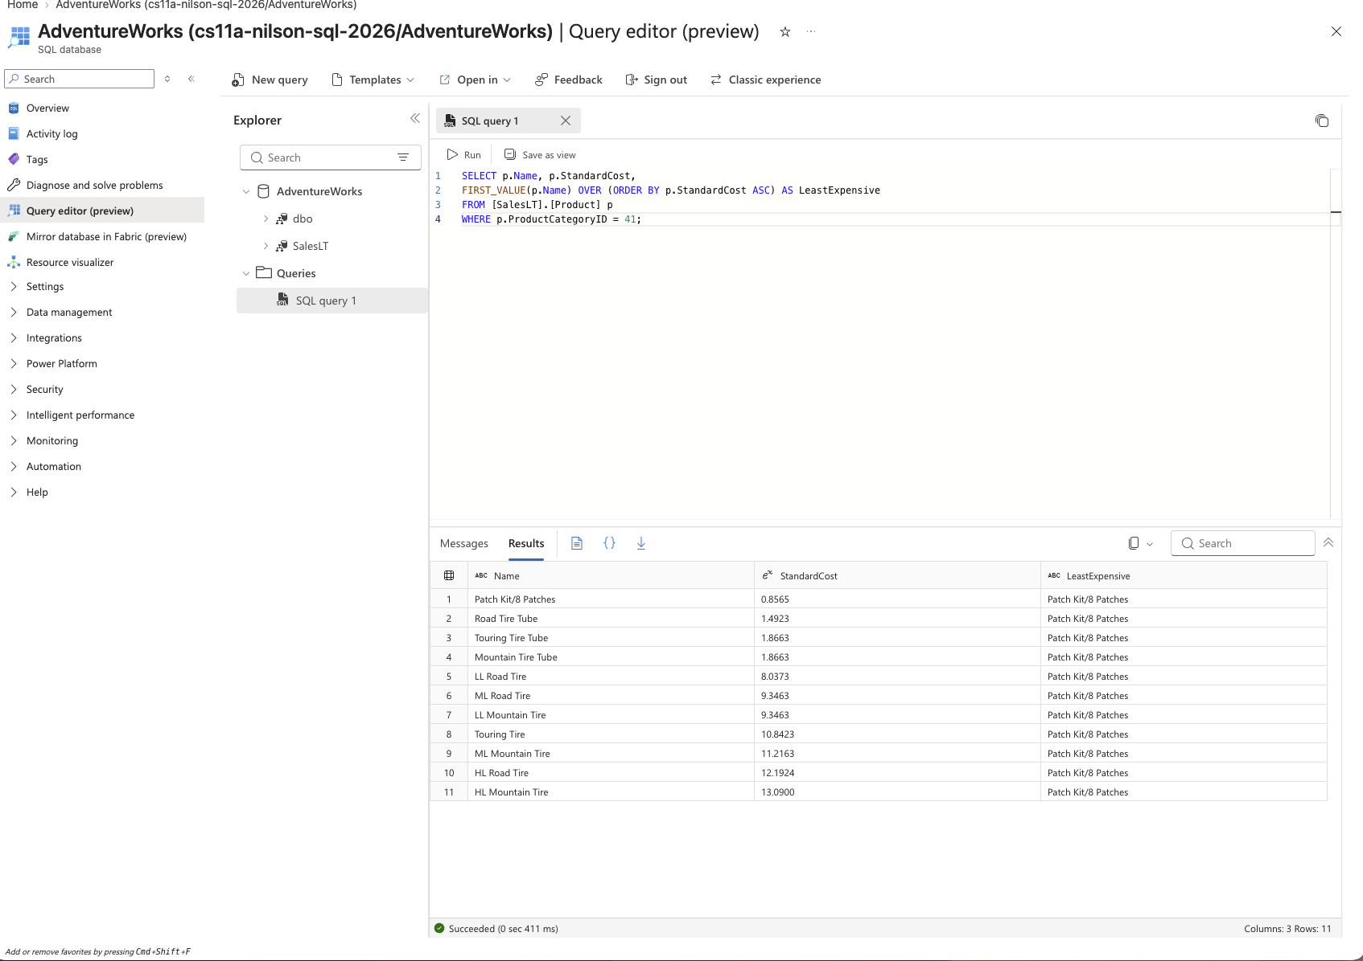

Technical: What is the command for? Why would you use the command?
FIRST_VALUE is a window function that returns the value of an expression from the first row of a window frame, defined here by ORDER BY StandardCost ASC within ProductCategoryID 41. It is used to attach the value from the top-ranked row, the cheapest product in the category, to every row in the result set without writing a separate self-join or subquery.
Application: What type of business user needs this information? Why does it need this information?
A procurement or product manager could use this to instantly see, next to every product in a category, what the lowest cost item in that category is, which is useful for cost comparison reporting.

1b. Analytic Function with LAST_VALUE
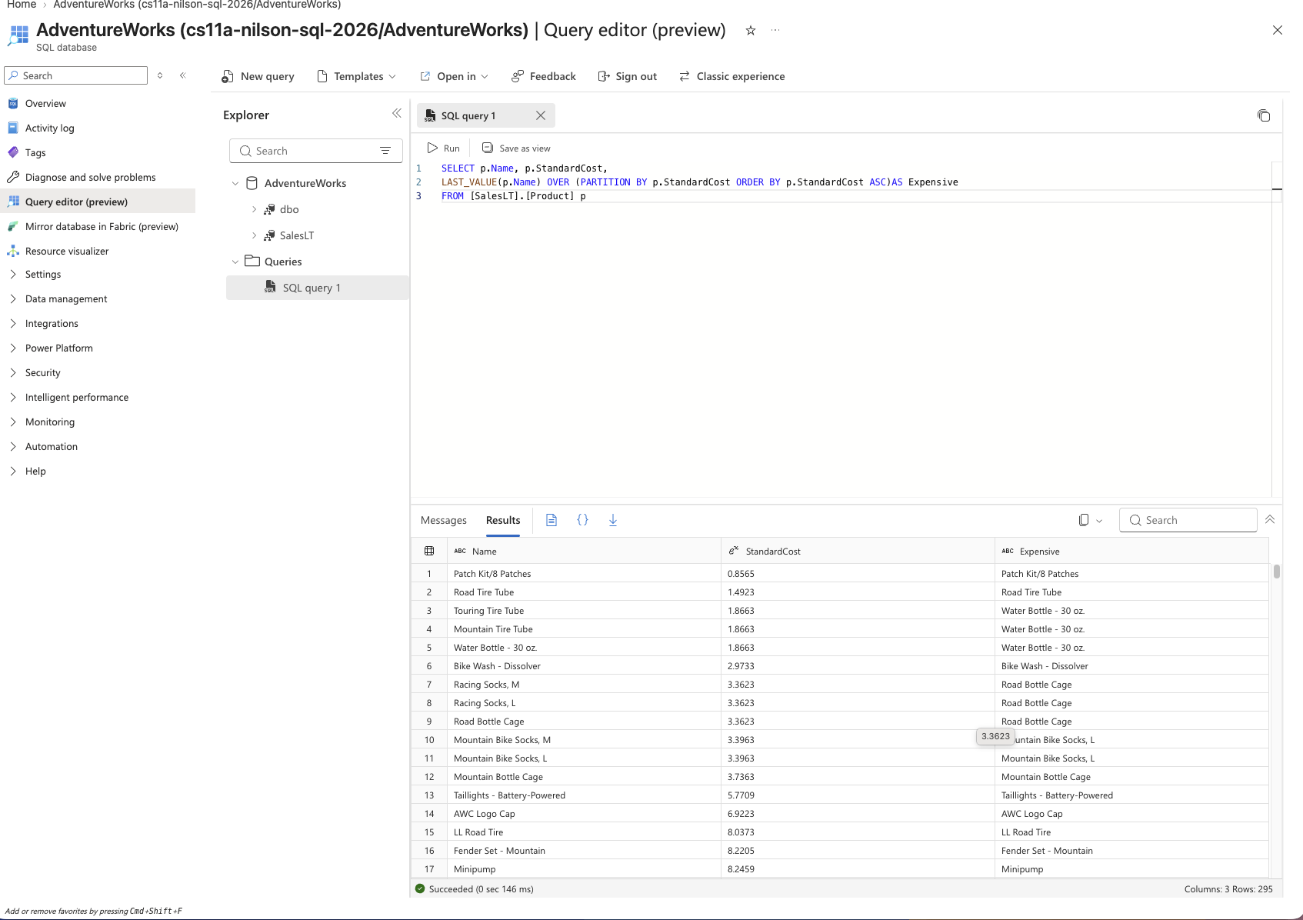

Technical: What is the command for? Why would you use the command?
LAST_VALUE returns the value from the last row of the window frame. Here it is partitioned by StandardCost and ordered by StandardCost ascending. Because the default frame only looks from the start of the partition to the current row, the "last" value within each partition ends up being the current row itself, so each product effectively shows its own name grouped by matching cost.
Application: What type of business user needs this information? Why does it need this information?
A pricing analyst could use this pattern to identify groups of products that share the exact same standard cost, which is useful for spotting pricing tiers across a catalog.

1c. Analytic Function with PERCENT_RANK
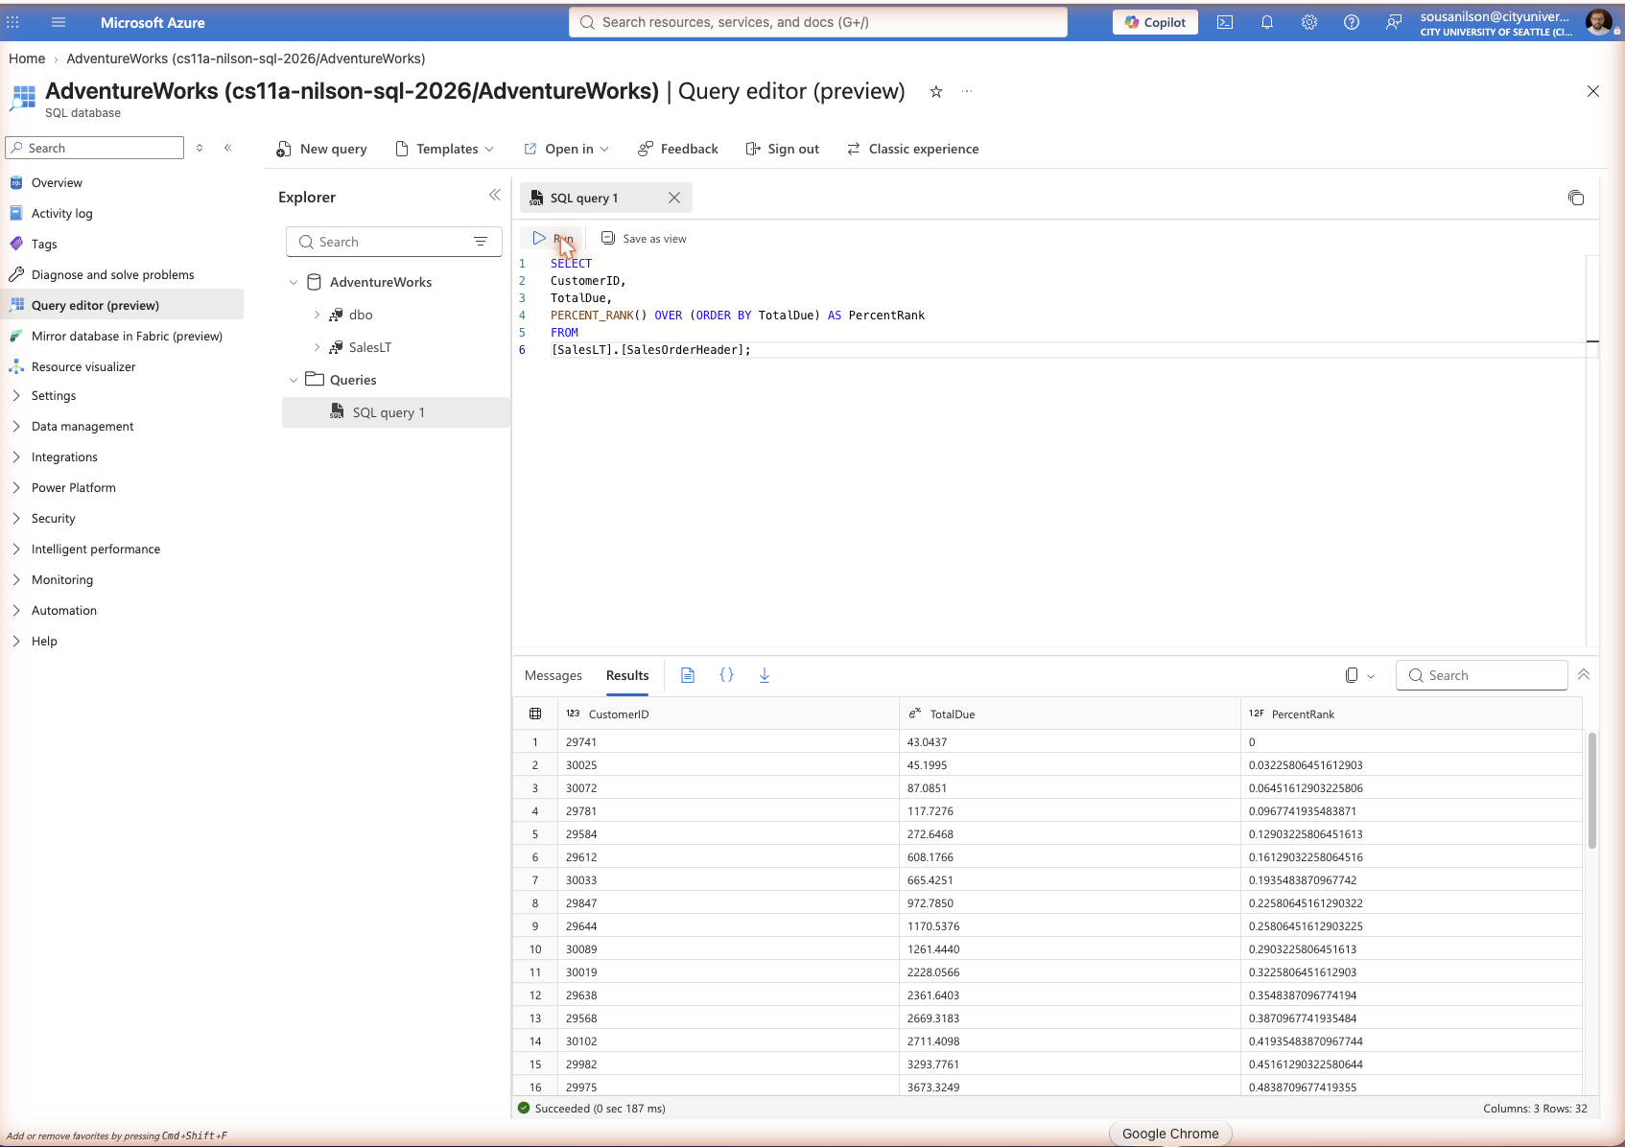

Technical: What is the command for? Why would you use the command?
PERCENT_RANK calculates the relative rank of each row as a percentage, from 0 to 1, of all rows in the result set based on the ORDER BY column. It is used to see where a value falls within the overall distribution of the data.
Application: What type of business user needs this information? Why does it need this information?
A finance or sales analyst could use this to see where each order's TotalDue falls relative to every other order, for example identifying that a given order is in the top five percent of order values.

1d. Ranking Function with RANK
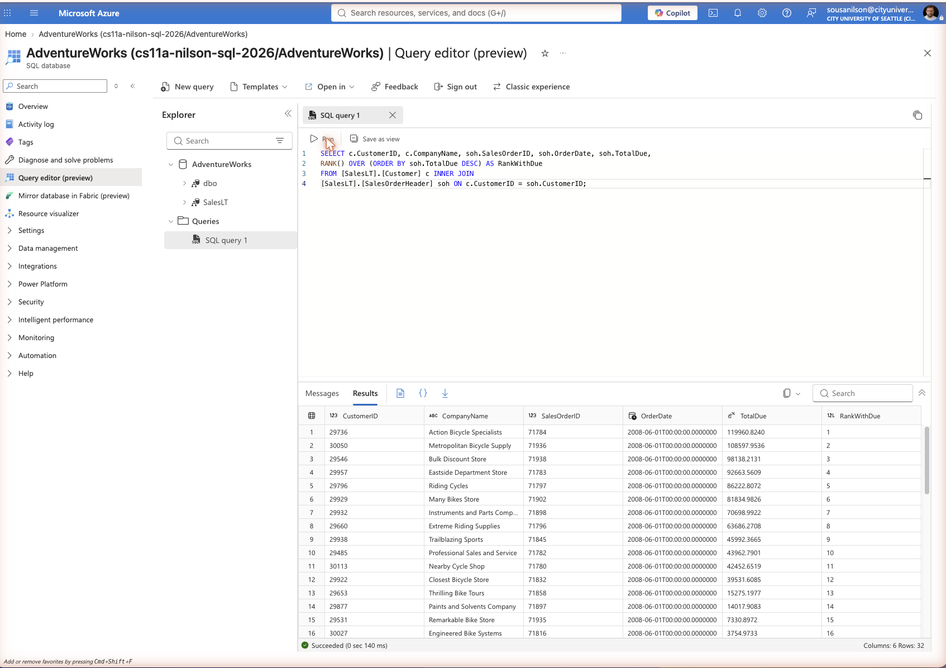

Technical: What is the command for? Why would you use the command?
RANK() assigns a ranking number to each row based on the ORDER BY column, with tied values receiving the same rank and a gap left in the numbering afterward. Combined with an INNER JOIN between Customer and SalesOrderHeader, this ranks every order from highest to lowest TotalDue.
Application: What type of business user needs this information? Why does it need this information?
A sales manager could use this to build a leaderboard of the largest orders and the customers behind them, useful for tracking top accounts or setting sales targets.

1e. String Function with REVERSE
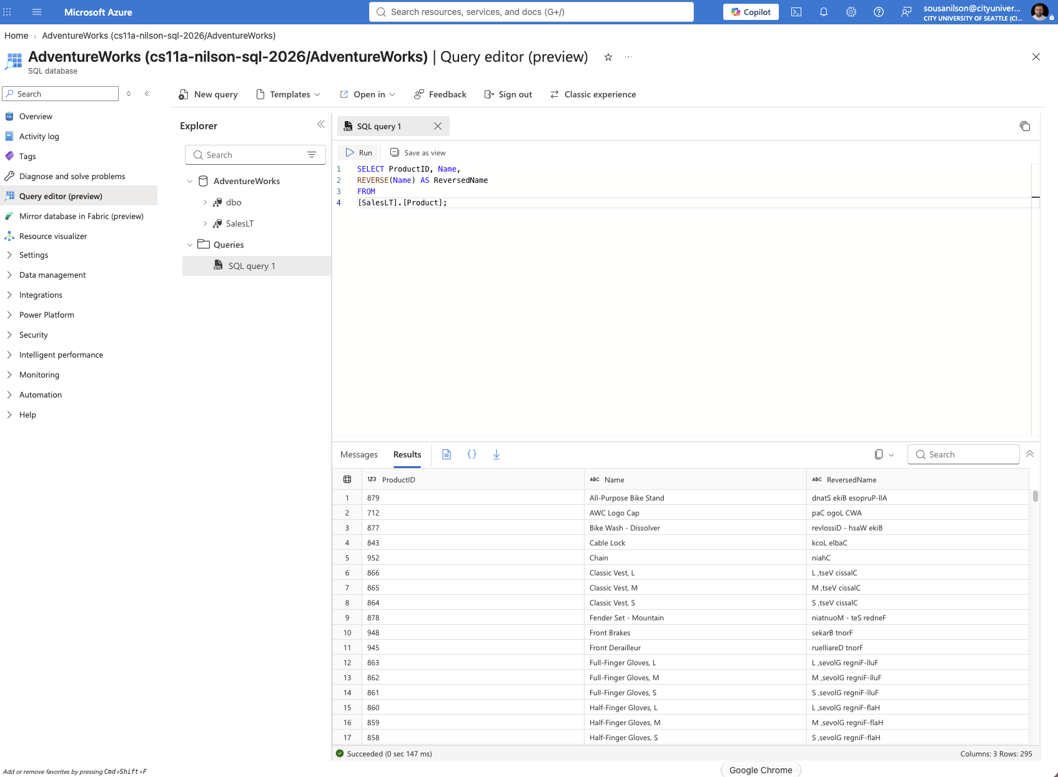

Technical: What is the command for? Why would you use the command?
REVERSE reverses the order of characters in a string. Here it is applied to each product Name to produce a mirrored version of the text.
Application: What type of business user needs this information? Why does it need this information?
This function is more of a developer utility than a typical business report, but it could support a data quality team building simple string pattern or palindrome checks, or a developer generating obfuscated reference codes from existing text values.

2a. Creating a Stored Procedure
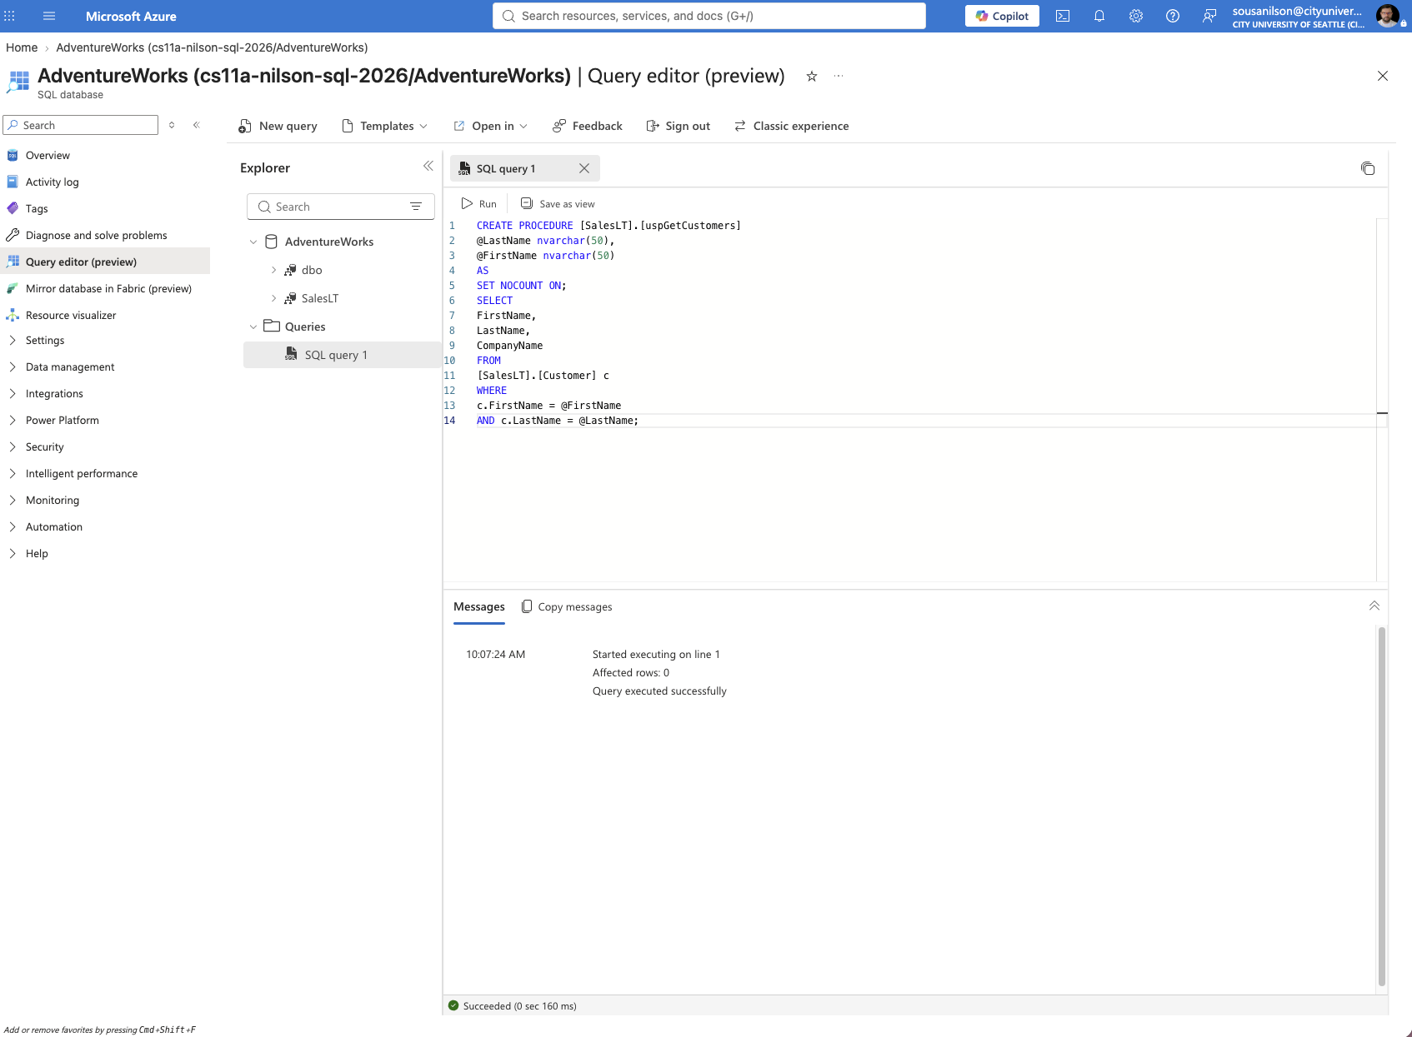

Technical: What is the command for? Why would you use the command?
CREATE PROCEDURE defines a reusable, named block of T-SQL that accepts input parameters and can be executed repeatedly without rewriting the query each time. Here it creates uspGetCustomers, which takes a last name and first name and returns matching customer records.
Application: What type of business user needs this information? Why does it need this information?
A customer service representative or an internal support tool could call this procedure to instantly look up a customer's company by name, without needing to know or write raw SQL.

2b. Modifying a Stored Procedure
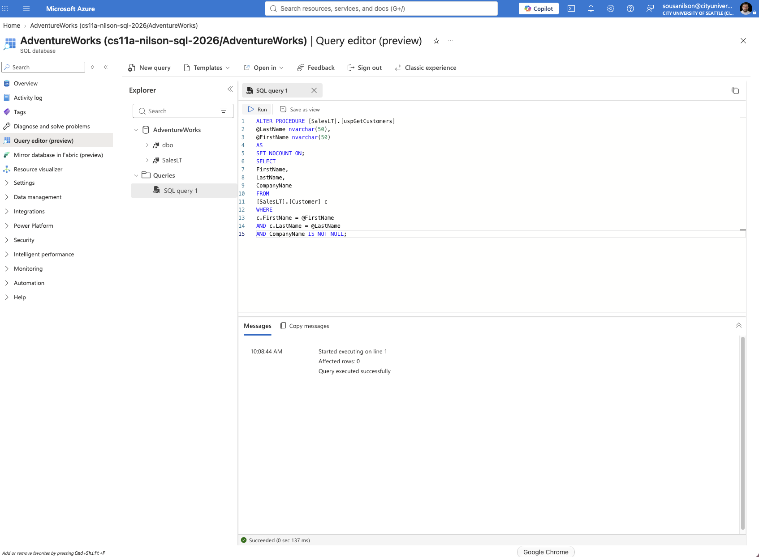

Technical: What is the command for? Why would you use the command?
ALTER PROCEDURE redefines an existing procedure's logic while keeping its name and permissions intact. Here it adds a filter so that only customers with a non-null CompanyName are returned.
Application: What type of business user needs this information? Why does it need this information?
This refinement is useful for a support tool that specifically needs to find business customers with a listed company, excluding individual or non-business customers from the lookup results.

2c. Executing a Stored Procedure
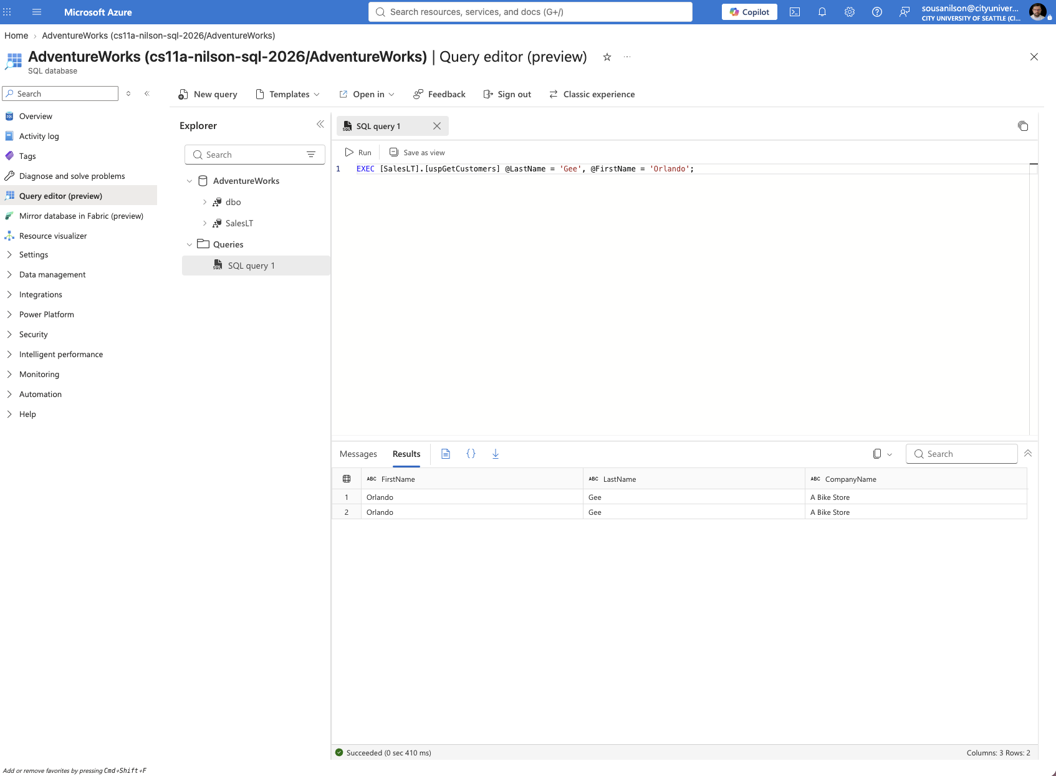

Technical: What is the command for? Why would you use the command?
EXEC runs a stored procedure, and passing arguments as @ParameterName = value lets you supply them by name rather than by position, making the call self-documenting and independent of parameter order.
Application: What type of business user needs this information? Why does it need this information?
A support or sales tool integrating this procedure would call it this way to keep the code readable and less error-prone, especially as more parameters get added over time.

2d. Executing a Stored Procedure Part 2
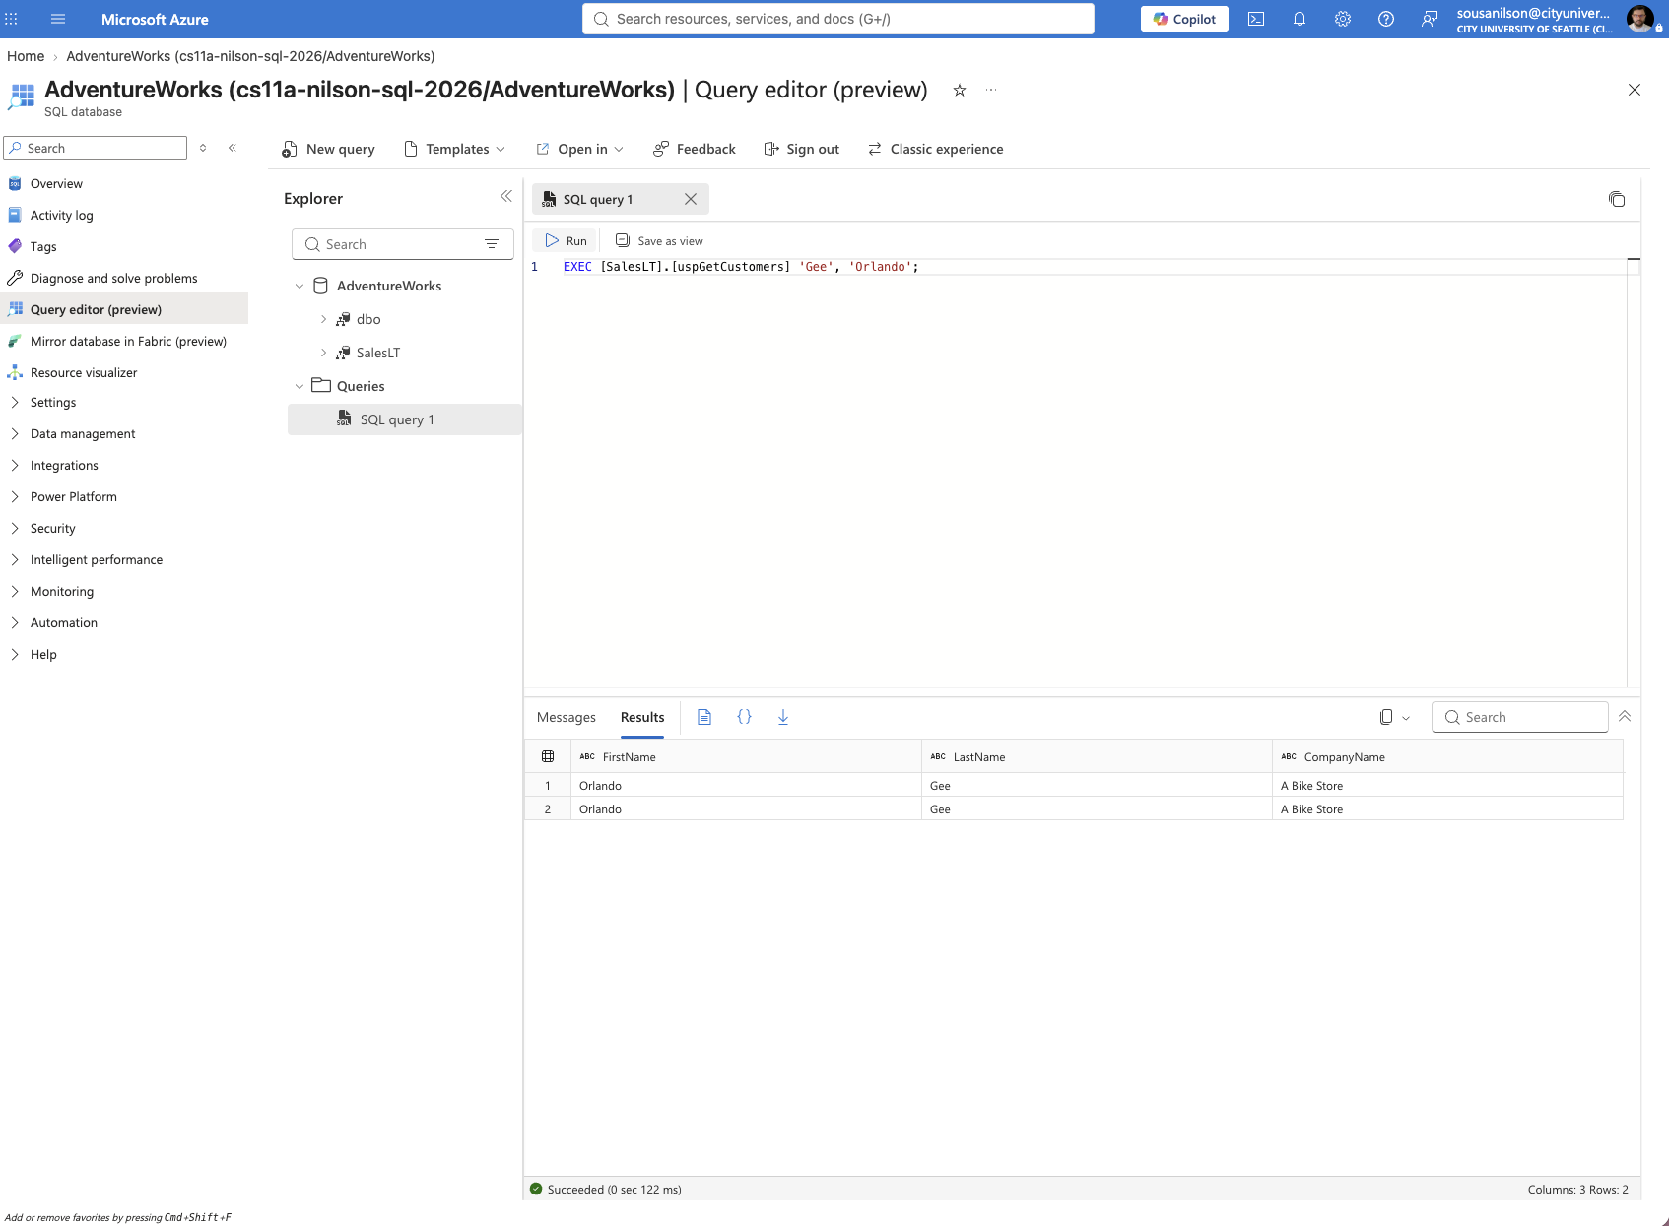

Technical: What is the command for? Why would you use the command?
This calls the same procedure by passing values in positional order, matching the order the parameters were declared (@LastName, then @FirstName), without naming them, and produces the identical result as the named version.
Application: What type of business user needs this information? Why does it need this information?
Same use case as the named-parameter call. Positional calls are common for quick ad hoc testing in the query editor, though named parameters are usually preferred in production application code for clarity.

2e. Rename a Stored Procedure
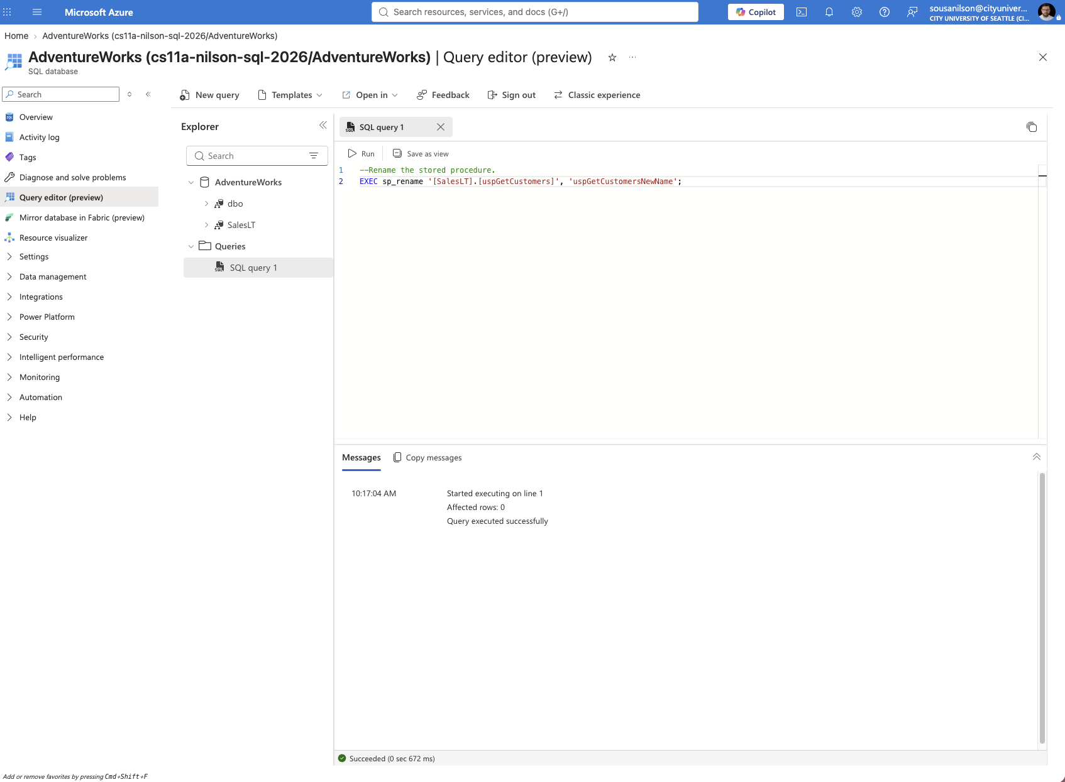

Technical: What is the command for? Why would you use the command?
sp_rename is a system stored procedure used to rename an existing database object, in this case renaming the stored procedure from uspGetCustomers to uspGetCustomersNewName, without needing to drop and recreate it.
Application: What type of business user needs this information? Why does it need this information?
A database administrator might use this when standardizing naming conventions across procedures, or when refactoring a system without immediately breaking every existing reference to the old name.

2f. Recompile a Stored Procedure
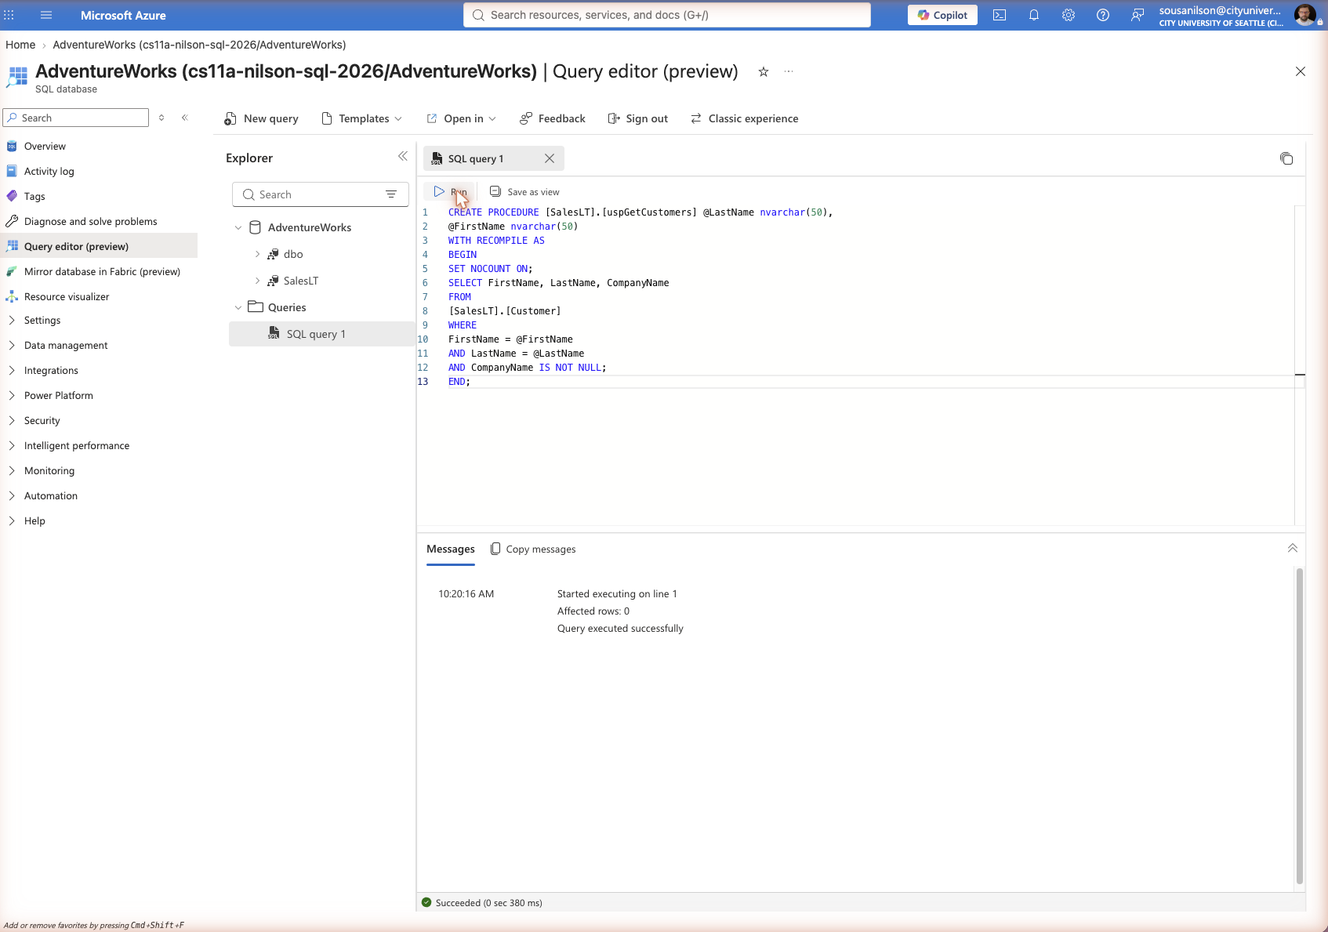

Technical: What is the command for? Why would you use the command?
WITH RECOMPILE tells SQL Server to generate a fresh execution plan every time the procedure runs instead of reusing a cached one. This was combined with recreating uspGetCustomers under its original name, which was free again after the earlier rename, keeping the CompanyName IS NOT NULL filter inside a BEGIN and END block.
Application: What type of business user needs this information? Why does it need this information?
A database administrator might use WITH RECOMPILE for procedures whose optimal query plan varies a lot depending on the input parameters, ensuring each execution gets a plan tuned to its actual arguments rather than a possibly suboptimal cached plan.

3. Create Views
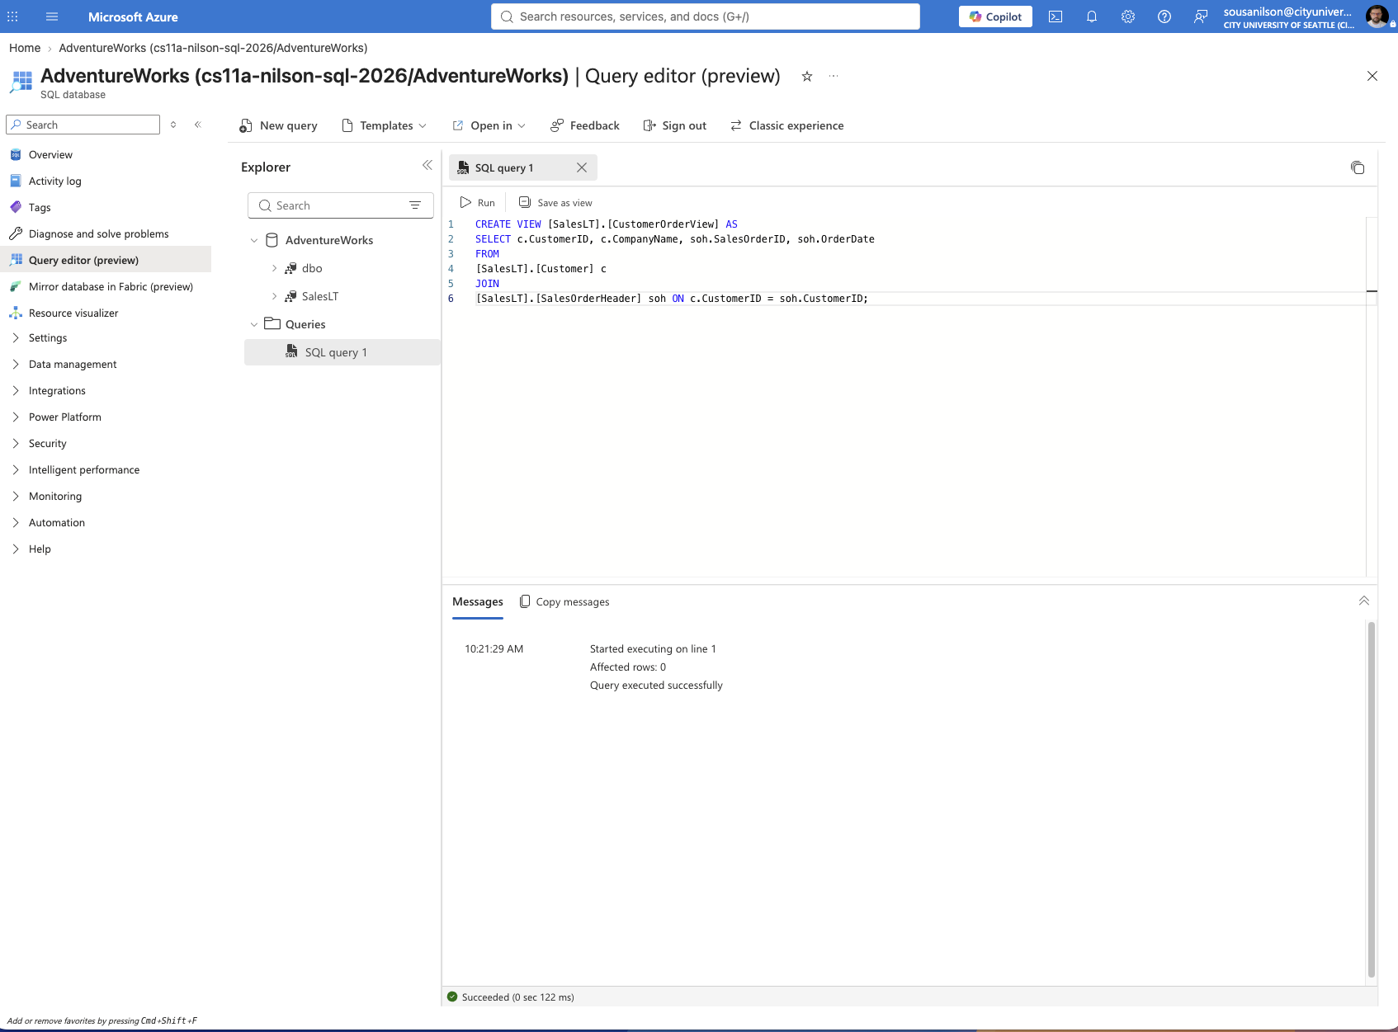

Technical: What is the command for? Why would you use the command?
CREATE VIEW defines a saved, reusable query, CustomerOrderView, that joins Customer and SalesOrderHeader, so that combined data can be queried directly without rewriting the underlying join every time it is needed.
Application: What type of business user needs this information? Why does it need this information?
A reporting team could use this view as a simplified, stable data source for dashboards or exports, without needing direct access to the full Customer and SalesOrderHeader tables.

3a. Querying the created view
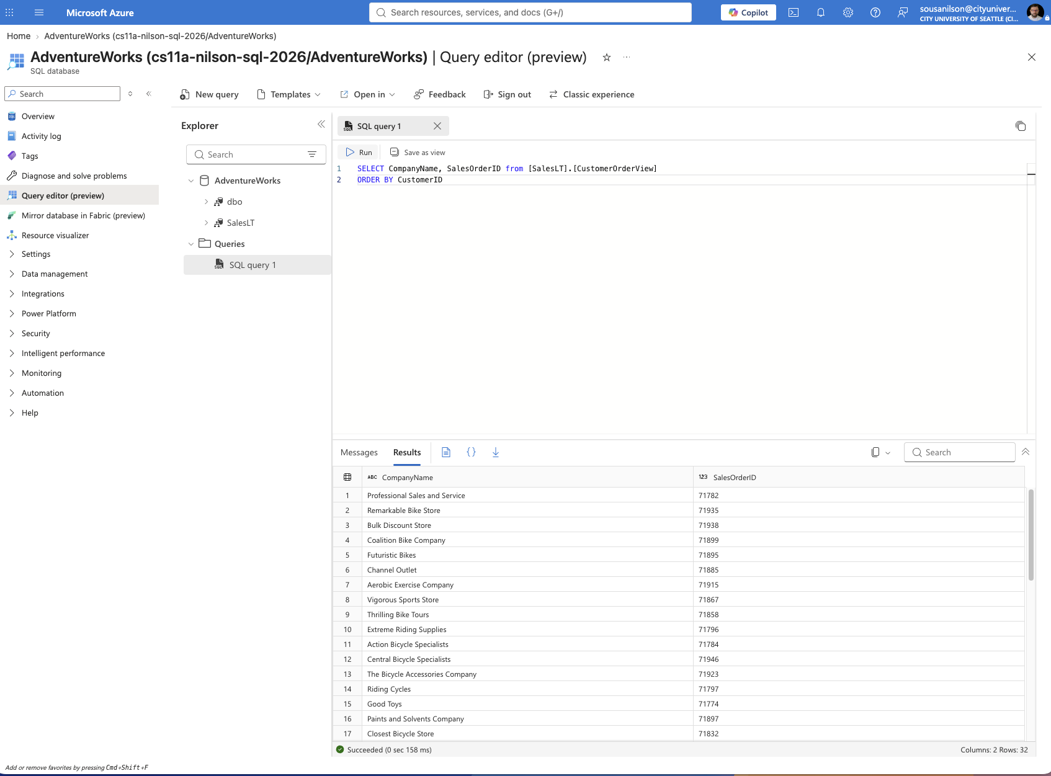

Technical: What is the command for? Why would you use the command?
This runs a standard SELECT against the view exactly like it would against a table, retrieving CompanyName and SalesOrderID ordered by CustomerID, confirming the view returns the joined data correctly.
Application: What type of business user needs this information? Why does it need this information?
A sales representative or account manager could use this simplified view to quickly pull each company's order IDs without needing to understand or write the underlying join logic.

3b. Modify Data through a View
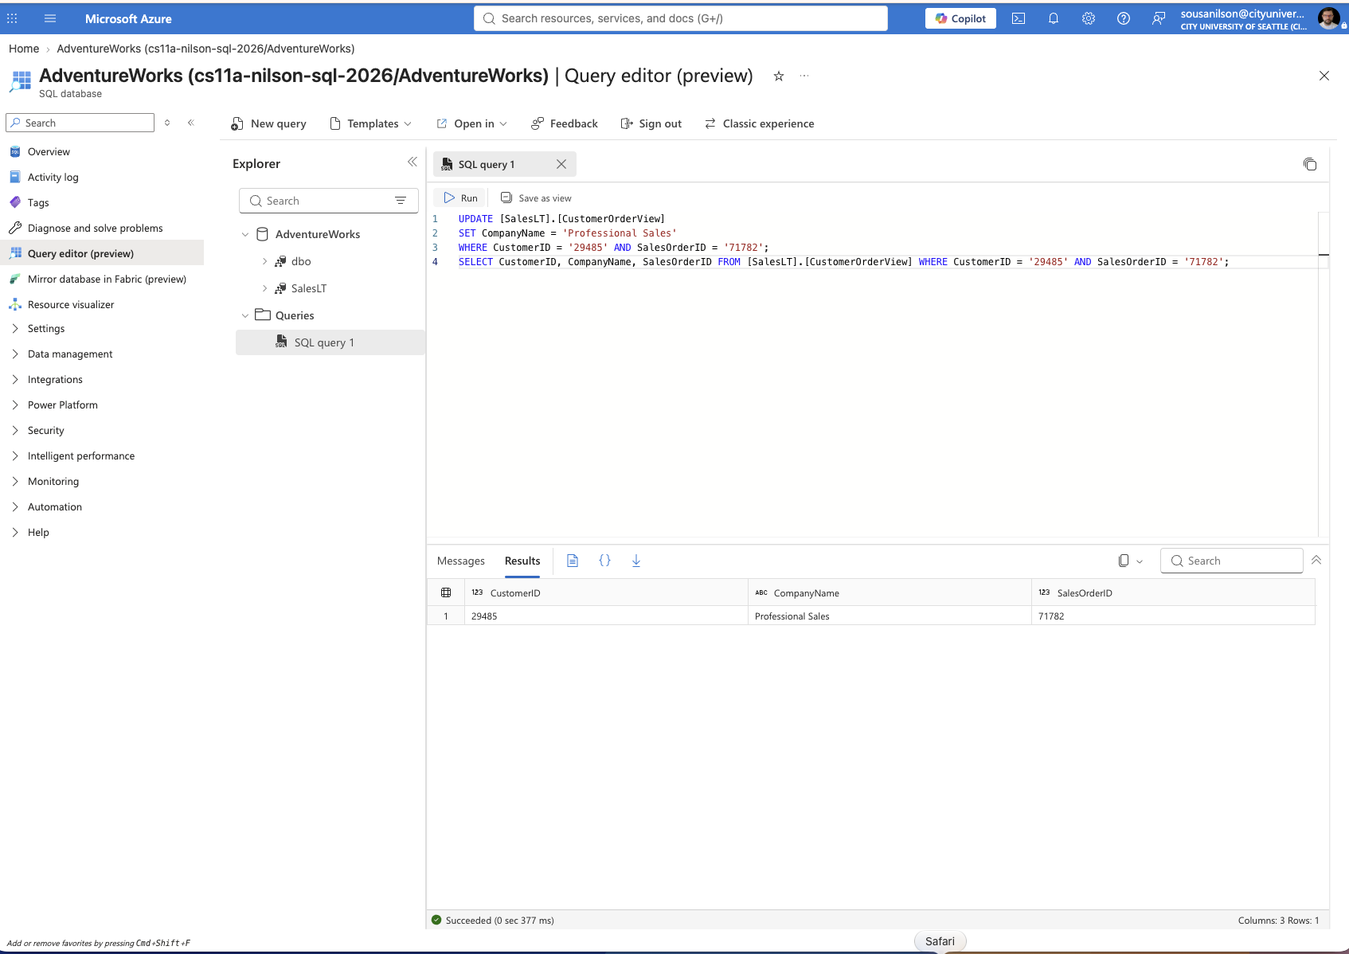

Technical: What is the command for? Why would you use the command?
This UPDATE targets the view directly. Because the updated column, CompanyName, comes from a single base table (Customer), SQL Server is able to translate the change back to that underlying table through the view. The follow-up SELECT confirms the change: CompanyName is now "Professional Sales" for CustomerID 29485 and SalesOrderID 71782, updated from its previous value of "Professional Sales and Service" seen in the view query from the previous step.
Application: What type of business user needs this information? Why does it need this information?
A support agent could correct a customer's company name directly through the view, for example during account cleanup, without needing UPDATE permissions on the full Customer table, since the view can be granted narrower access.

